Project Title: Custom Website Creation Platform

*Course code: Tietokannat LV2425*

Name: Laiba Khan

Date: 5.10.2024 - 28.10.2024

*Students: 1*

# Purpose of the System:

The system aims to manage contact messages, Feedback and Booking of Appointments submitted by users through a web interface.

Users of the System:

## Administrators:

* Manage and retrieve messages.

## Users:

* Submit contact messages, Feedback and Booking Appointments via the web interface.

## Operating Environment:

The system will run on a local server using PHP and MariaDB for the database.

## System Users:

Users who submit messages and administrators who manage the database.

## Limitations:

The application is limited to the local server and may require internet access for remote hosting in the future.

## Required Functions:

1. Add new contact messages (via form submission).
2. Retrieve contact messages (displaying all messages).
3. Delete contact messages (admin functionality).

## Interface Description:

A web-based interface is developed using HTML, CSS, and JavaScript to interact with the database.Usability and Accessibility Requirements:

The interface is user-friendly and accessible on both desktop and mobile devices.

Entity-Relationship Diagram

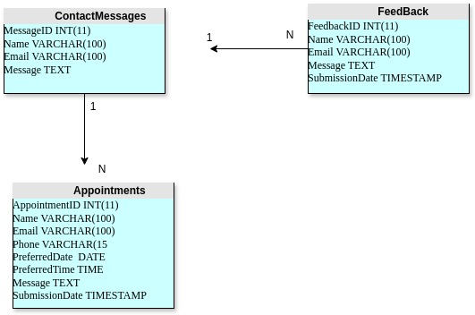

# Challenges Faced

## Issues with Database Connection:

Encountered difficulties connecting the application to the database. This issue was resolved by:

* Verifying connection strings in the configuration files.
* Ensuring that the database server was running and accessible.

## Data Validation Issues:

Faced challenges with ensuring that the data submitted by users met the required format and constraints. This was addressed by:

* Implementing JavaScript validation functions that check for empty fields and validate email formats.
* Providing feedback messages to users when input errors occur, thus improving data quality.

### You can access the user interface at the following link, which is created using ngrok:

<https://finer-shrew-seemingly.ngrok-free.app/CustomWebsiteCreationPlatform/>

Please note that this link is temporary. If it doesn’t work for any reason, you can refer to the photos of my website provided below.

**Home Pages**

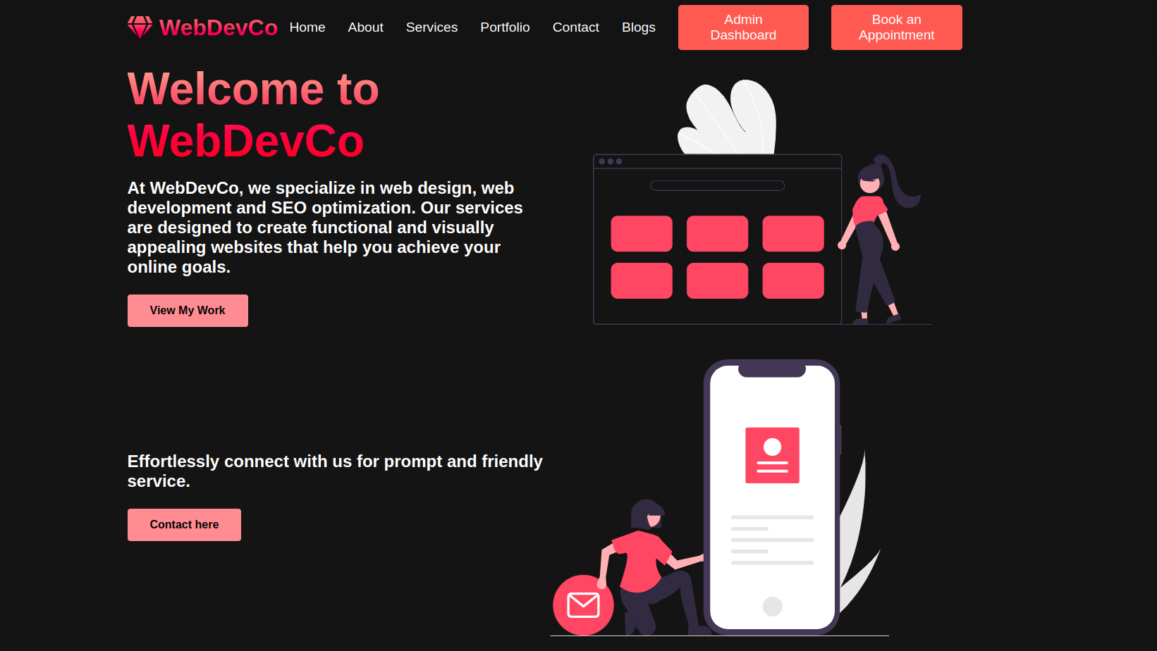

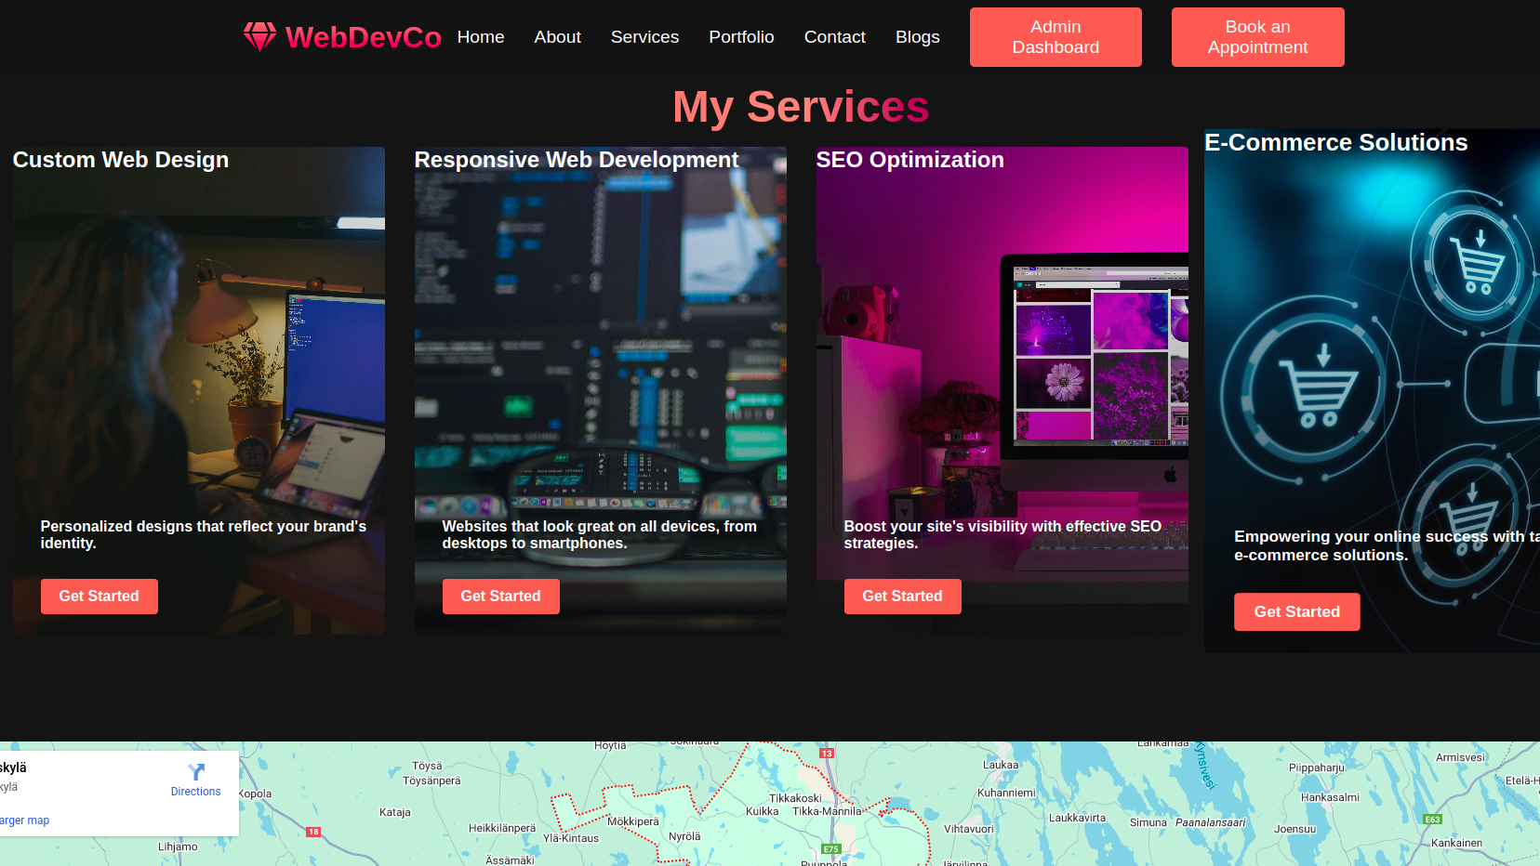

**About Page**

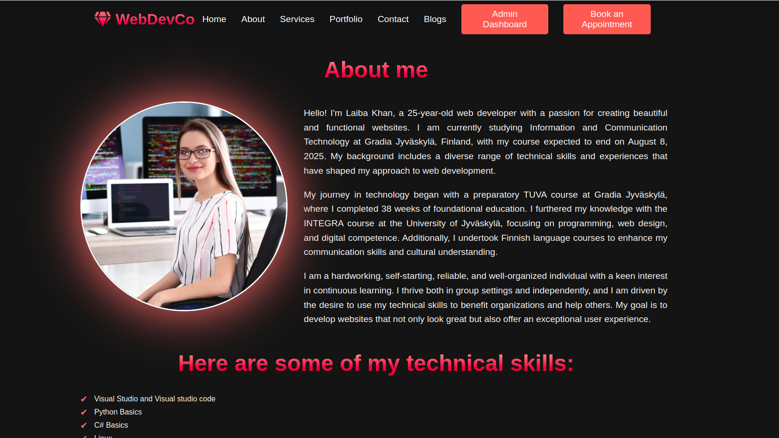

**Services Pages**

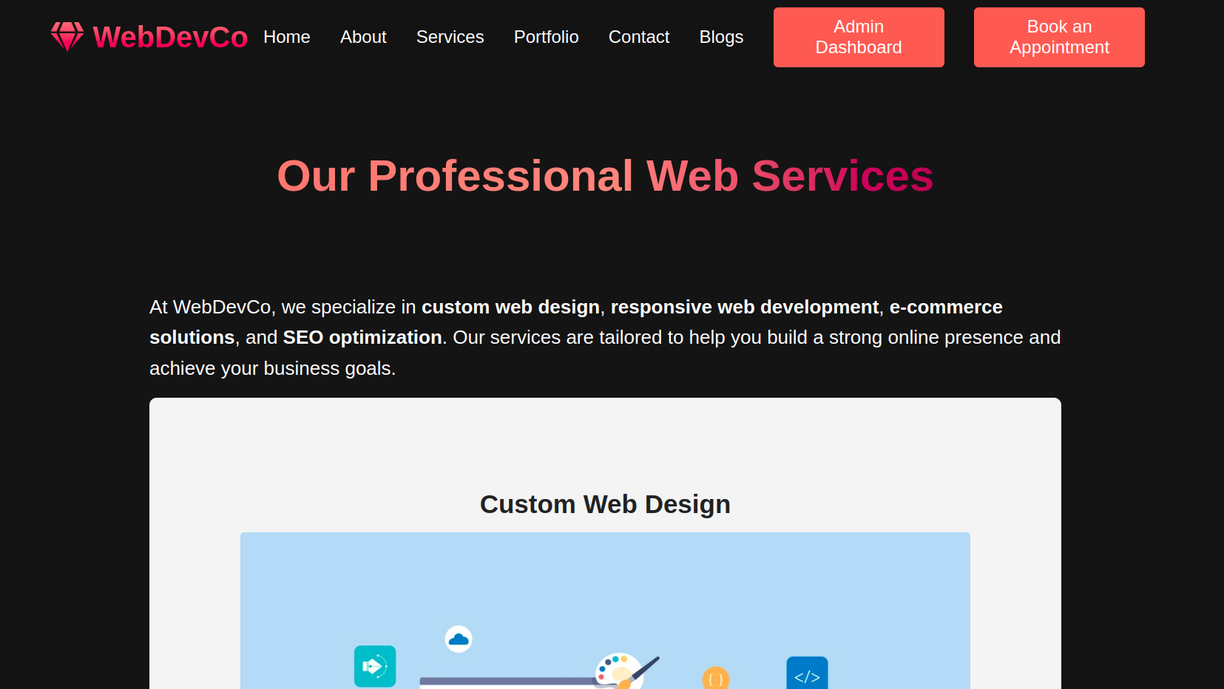

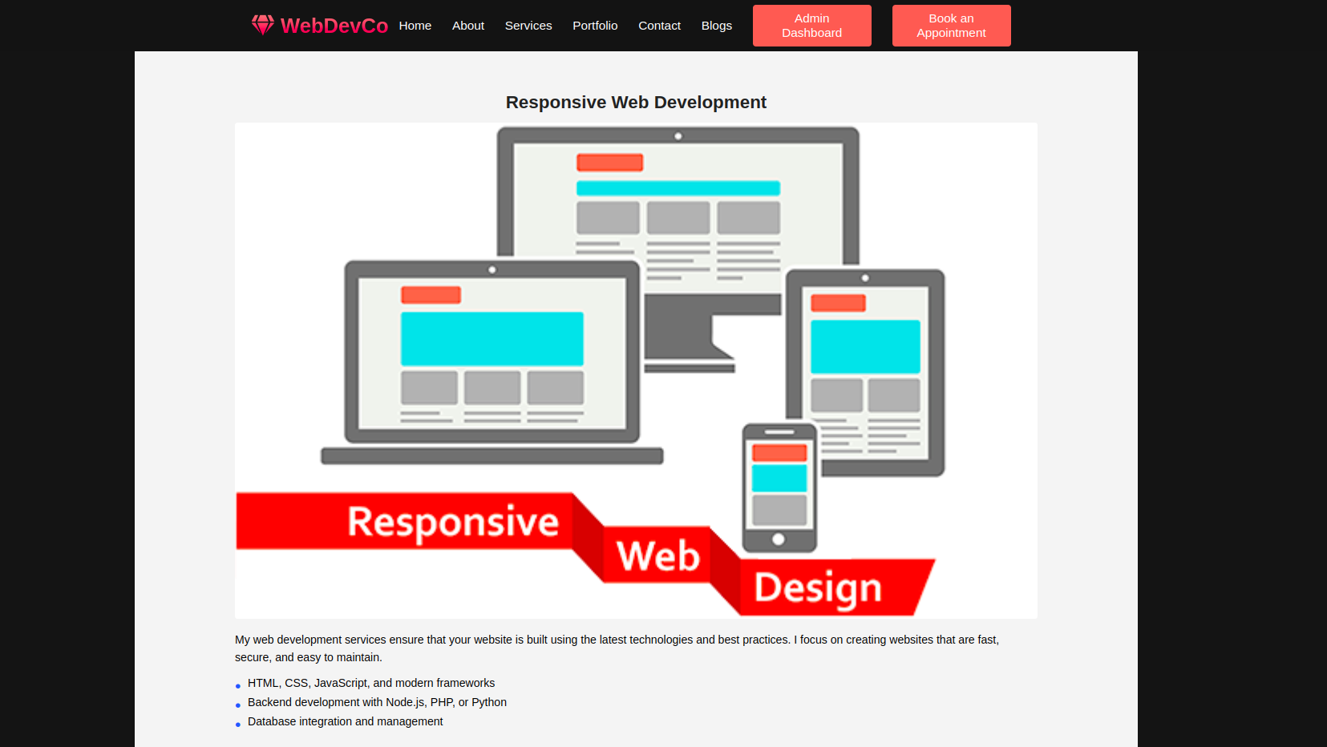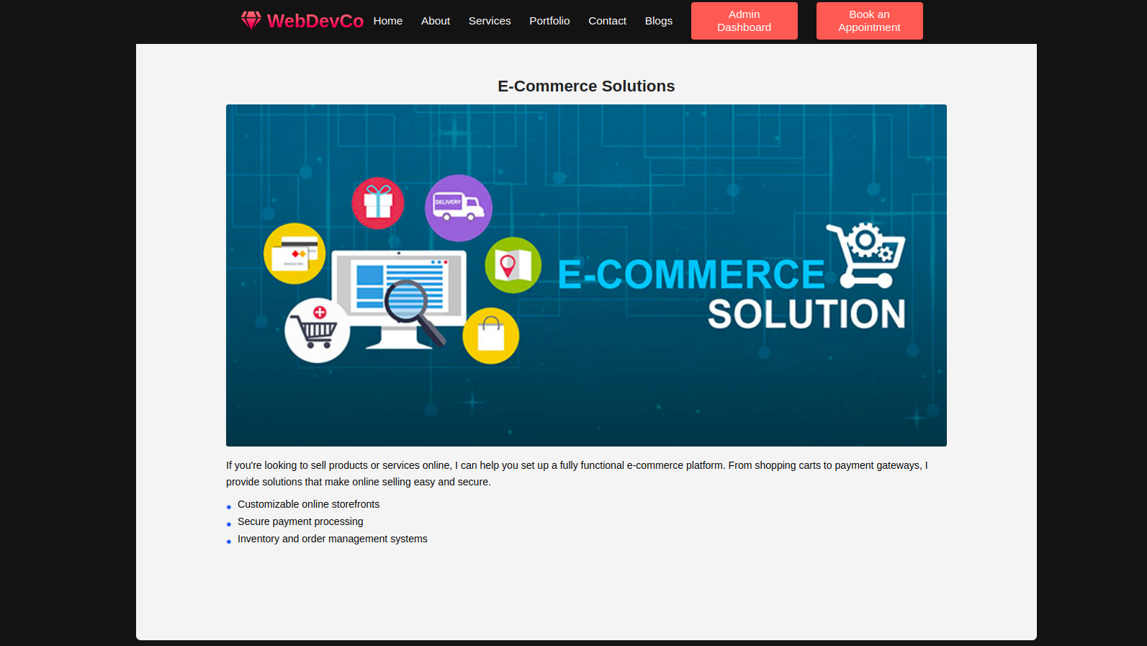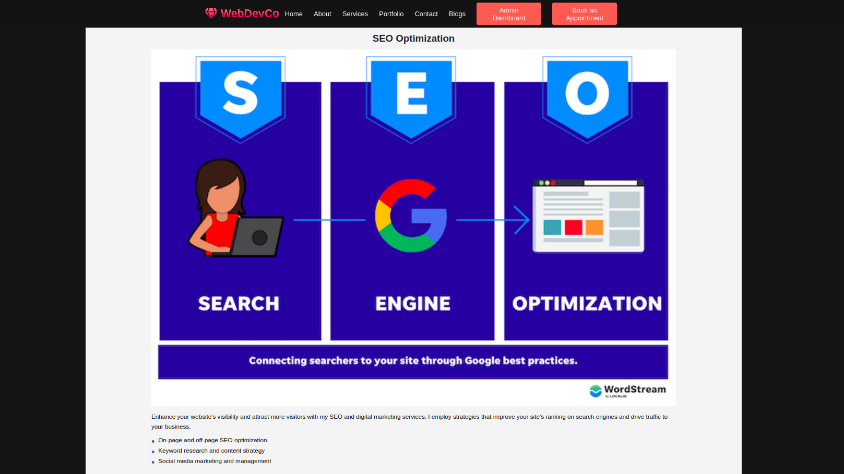

**Portfolio Page**

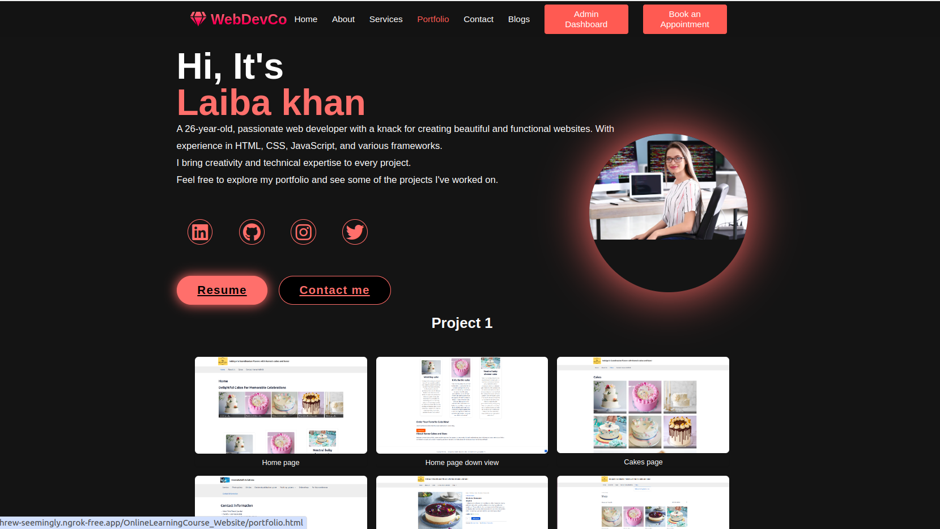

**Contact Page**

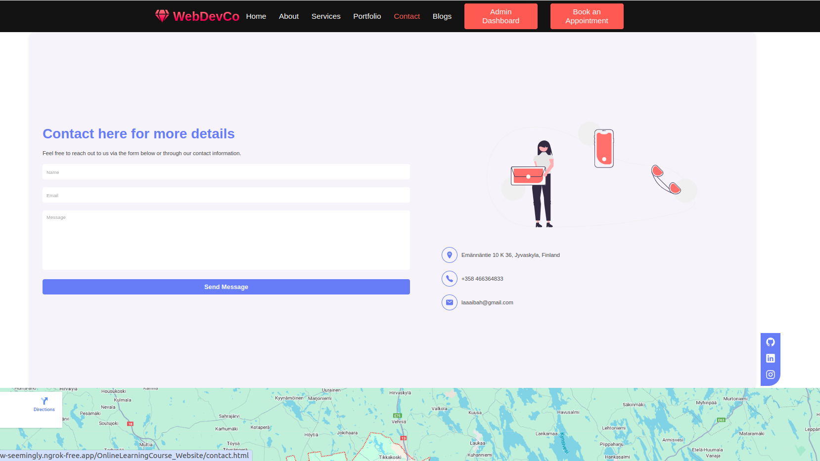

**Feedback Page**

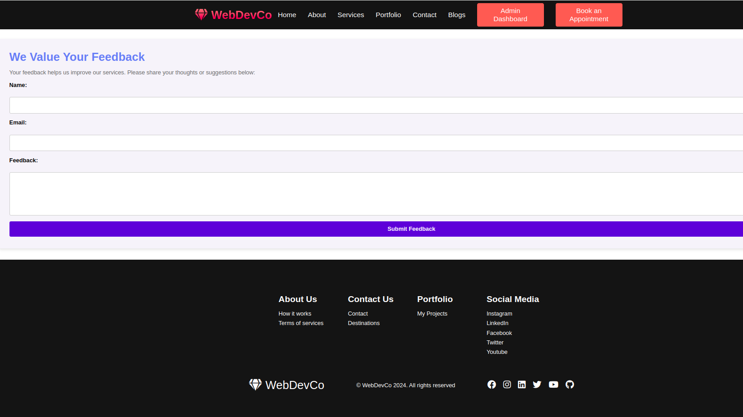

**Blogs Pages**

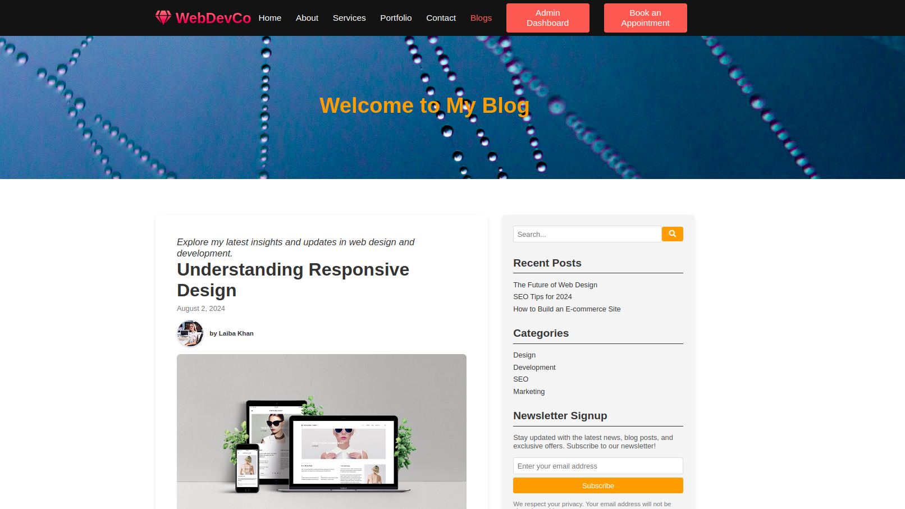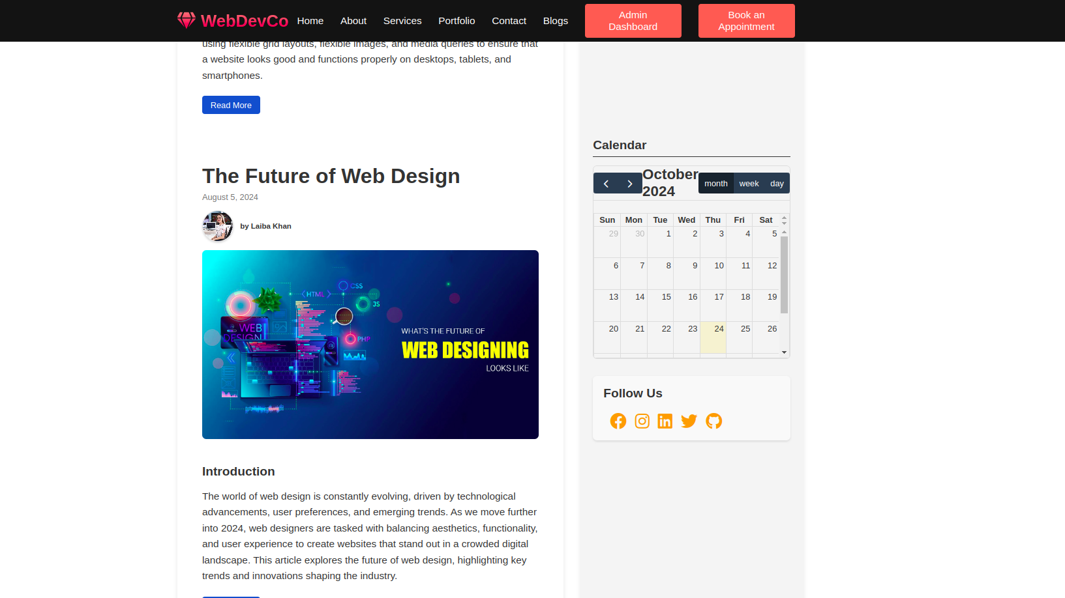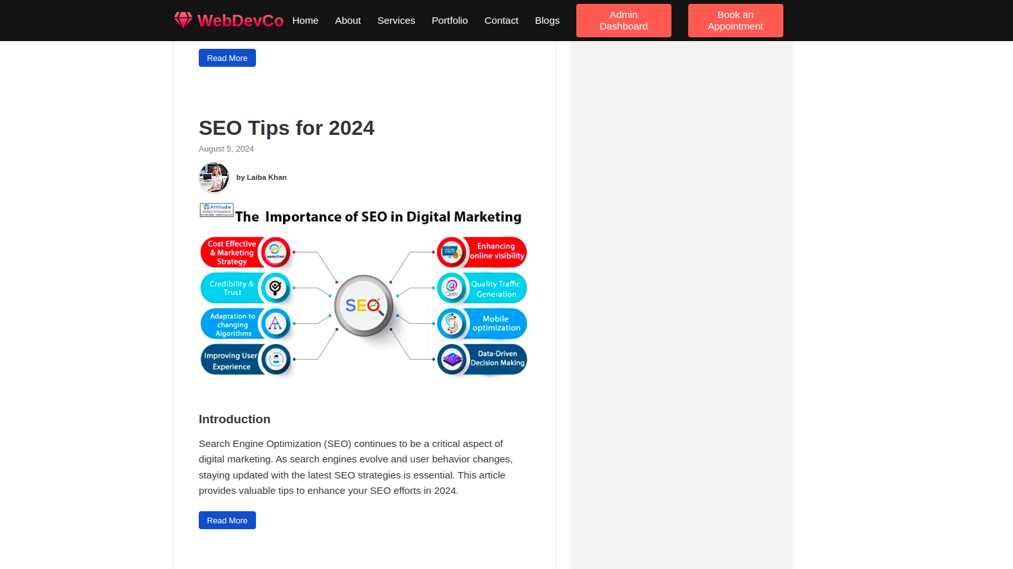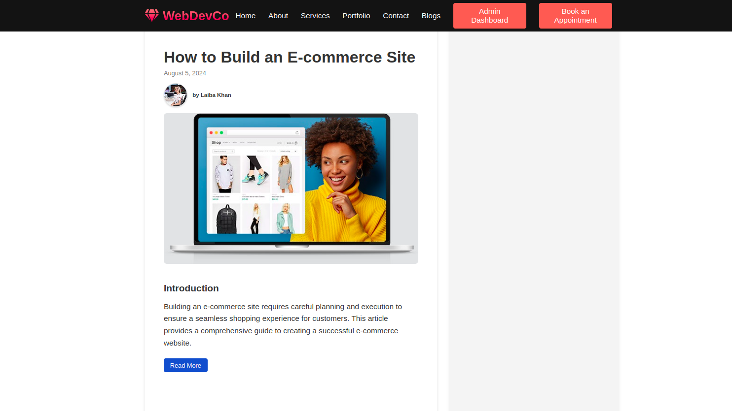

**Appointment Booking Page**

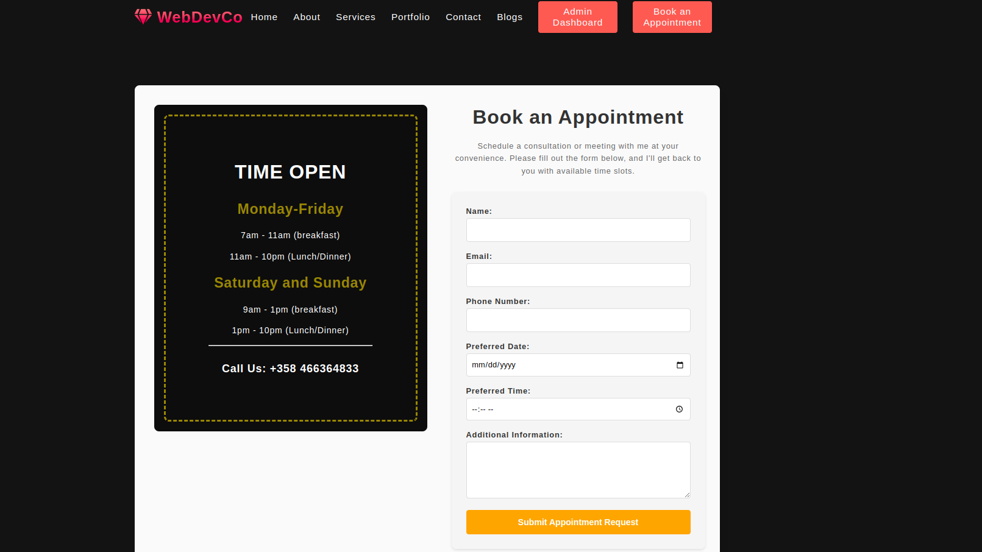

# Database

